MyData User Guide
You can select any of the section titles listed to go directly to that section.
Contents
MyData Overview 1
MyData Use Cases and Limitations 2
MyData Access & Account Management 2
Service Accounts 2
Password Maintenance 2
Whitelist Static IP Addresses 3
Job Aid Feedback 3
Appendix A: Setup 4
Prerequisites 4
Client Computer Setup 4
Microsoft Tip 4
Testing your MyData Connection 5
Microsoft Tip 6
Troubleshooting Connectivity 7
Microsoft Tip 7

MyData Overview
This job aid provides setup information and sample connections to help contracted customers connect to the MatrixCare MyData database (Azure SQL Database). Once connected to MyData, you can extract your organization’s data and use the reporting tool of your choice to work with your data. MyData is a contracted analytics solution intended for customers with existing investments in people, software and intellectual property to integrate and analyze company data. Using data from the table views available through MyData, customers can create their own reports, calculations and metrics.

MyData Use Cases and Limitations
MyData use cases include:
- Utilizing your organization’s MatrixCare Home Health & Hospice data for supplemental analytical reporting to complement transactional reports available within AFO.
- Enterprise-wide analytics requiring data from MatrixCare Datamart
- Population-wide analytics across Business Units and Care Locations
MyData should not be used for:
- Transactional reports
- Systems requiring real-time data
- Compliance reporting
For optimal performance, it is recommended that you extract the data populated in your MyData DataMart database to your own database server and use the extracted copy for consumption by the reporting tool/ application.

MyData Access & Account Management

Service Accounts
A shared Service Account is created for your company to access MyData. This shared service account username and a temporary password will be provided to you by your MatrixCare Home Health & Hospice Implementation Team. You will need to update your service account password before it can be used to connect to MyData. It is the responsibility of your agency to control access and monitor the usage of this shared service account.

Password Maintenance
Your initial MyData Service Account is created with a temporary password. You will need to update the password before using it to connect to MyData. Please follow these steps to update your temporary password:
Navigate to https://login.microsoftonline.com/ on a web browser.
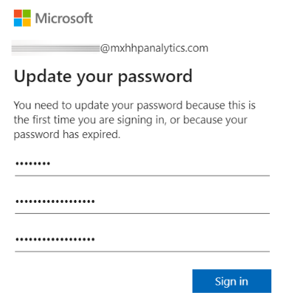
- Enter your MyData Service Account username and temporary password, adding @mxhhpanalytics.com
to the end of the username.
- When prompted to Update your password, enter your
current temporary password and new password, and
select Sign in.
- Close the browser window after signing in successfully.
To reset your MyData Service Account password, please contact Support for assistance. MatrixCare currently does not support a self-service user management mechanism for MyData.

Whitelist Static IP Addresses
As a prerequisite for MyData access, you will need to:
- Obtain a static IP address (IPv4) for the client computer that will be used for the MyData database connection.
- Communicate this static IP address to your contact in HHP Implementation team so it can be added to the whitelist on your MyData database firewall.
MatrixCare currently supports adding up to three individual IP addresses to the whitelist for each client. Whitelisting IP address ranges is not supported.

Job Aid Feedback
How helpful was this document? Click here to take a 2-question survey.
Note: Press Ctrl+Click to activate the link.

Appendix A: Setup

Prerequisites
Once registered for MyData, you will receive the following information from the MatrixCare Home Health & Hospice Implementation team:
- Your MyData database server endpoint. Example: testserver.database.windows.net
- Your MyData database name Example: bt-datamart-XYZ
- Your MyData Service Account credentials Example: username@domain.com
- Firewall rules on your client machine to allow outbound connections to port 1433
- Confirmation that your computer’s external static IP address is added to the whitelist on your MyData database firewall.

Client Computer Setup
You must install the following software on all computers from which your application or users will connect to your MyData database (Azure SQL Database):
- NET Framework 4.6 or later from https://msdn.microsoft.com/library/5a4x27ek.aspx
- Azure Active Directory Authentication Library for SQL Server (ADAL.DLL). Below are download links to install the latest SSMS, ODBC, and OLE DB driver that contains the ADAL.DLL library.
- SQL Server Management Studio
- ODBC Driver 17 for SQL Server
- OLE DB Driver 18 for SQL Server
You can meet these requirements by:
- Installing the latest version of SQL Server Management Studio or SQL Server Data Tools that meets the .NET Framework 4.6 requirement.
- SSMS installs the x86 version of ADAL.DLL.
  - SSDT installs the amd64 version of ADAL.DLL.
  - The latest Visual Studio f rom Visual Studio Downloads meets the .NET Framework 4.6 requirement, but does not install the required amd64 version of ADAL.DLL.
Your MyData database supports connections with a minimum TLS version of 1.2. Make sure this TLS version is supported and enabled on your computer.

Microsoft Tip
Configure Your Client Computers
- https://docs.microsoft.com/en-us/azure/azure-sql/database/authentication-aad-configure?tabs=azure-powershell#configure-your-client-computers

Testing your MyData Connection
You can use SQL Server Management Studio to test your MyData database connectivity.
- Start SQL Server Management Studio and in the Connect to Server dialog box enter the fully qualified domain name of your MyData endpoint (Example: testserver.database.windows.net)
- In the Authentication box, select Azure Active Directory – Password
- In the Username box, enter your MyData username in the format: username@domain.com.
- In the Password box, enter your MyData user password.
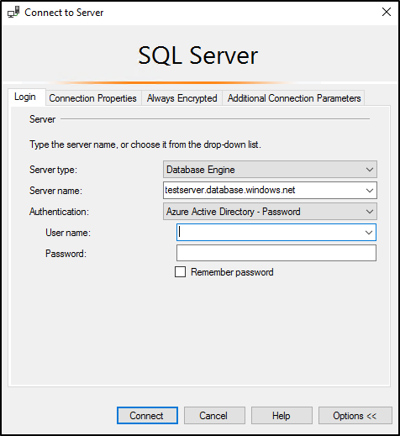
- Select the Options button, and on the Connection Properties page, in the Connect to database box, enter the name for your MyData database.
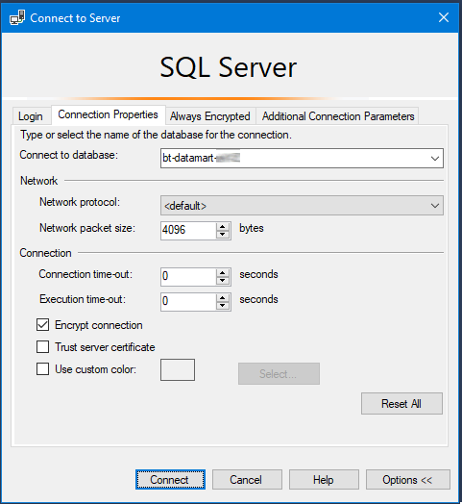
- Once connected, you should be able to see the MyData Views in the SSMS Object Explorer:
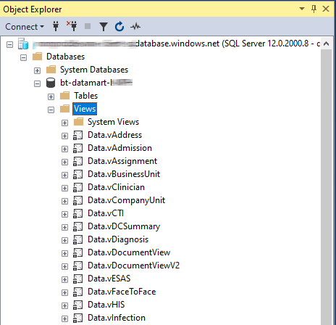
Enter a SQL query in SSMS to ensure you can view data.
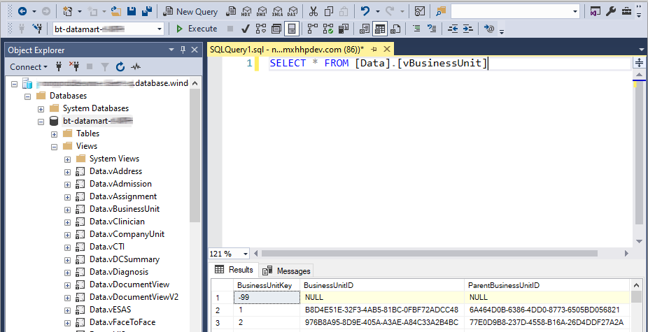

Microsoft Tip
Using an Azure AD Identity to Connect Using SSMS or SSD
- https://docs.microsoft.com/en-us/azure/azure-sql/database/authentication-aad-configure?tabs=azure-powershell#using-an-azure-ad-identity-to-connect-using-ssms-or-ssdt

Troubleshooting Connectivity
Use the following table when troubleshooting connectivity issues, or the Microsoft Tip below for other errors and general troubleshooting issues for Azure SQL.
# | Error | Resolution
1 | Your client IP address does not have access to the server | - Did you specify your MyData database name when testing your MyData connection?  - Are you connecting from the client computer with a whitelisted IP address?  - Has your client computer’s IP address changed since it was added to the whitelist?
2 | Error validating credentials due to invalid username or password | Did you enter your MyData credentials correctly?
3 | The server was not found or was not accessible | Did you enter the fully qualified domain name of the MyData Azure SQL server as the Server name?

Microsoft Tip
Troubleshoot Common Errors
- https://docs.microsoft.com/en-us/azure/azure-sql/database/authentication-aad-configure?tabs=azure-powershell#using-an-azure-ad-identity-to-connect-using-ssms-or-ssdt

Legal Notices
©2025 by MatrixCare
All Rights Reserved.
Disclaimer
All information presented herein is solely intended for employees of current customers in connection with their use of the MatrixCare/Brightree application as a supplement to training, and to illustrate how our solutions can be utilized by a typical company. Statements and examples used in the presentation are not intended to contradict or in any way override the written or verbal instructions of the customer (“Licensee”). The Licensee is responsible for establishing its own practices and procedures and making each of their employees familiar with them, including those related to the use of the MatrixCare/Brightree application. Nothing in this training material should be construed to be instructing any Licensee employee to violate any Federal, State, or other jurisdictional law or regulation; or to violate any aspect of the Licensee’s established practices and procedures. Licensee is encouraged to consult with its own regulatory and legal advisors For the avoidance of doubt, MatrixCare/Brightree uses a fake name generator to make up false or random names and addresses for inclusion into MatrixCare/Brightree training materials and it does not intend for these names and addresses to represent or relate to any real individual person or entity.
The information contained in this document is the copyrighted property of Brightree Home Health & Hospice, LLC and/or its affiliates. No part of this document may be reproduced, republished, translated, stored in a retrieval system, or transmitted in any form, or by any means, mechanical, photocopying, recording, or otherwise, without the prior written consent of Brightree Home Health & Hospice, LLC and/or its affiliates. Brightree Home Health & Hospice, LLC and/or its affiliates may take any action permitted by law to enforce its rights hereto.
The information contained in this document is subject to change without notice. The enclosed materials are not a contract and create no rights upon the reader or obligations of any kind on Brightree Home Health & Hospice, LLC and/or its affiliates. Brightree Home Health & Hospice, LLC and/or its affiliates reserve the right to make changes to any products or services described in this document at any time without notice. Brightree Home Health & Hospice, LLC and/or its affiliates shall not be liable for the actions or inactions of the reader in reliance upon the information contained in this document.
Trademarks
Brightree is a registered trademark of Brightree Home Health & Hospice, LLC. Any other product and company names used herein are the property of their respective owners.
Version
This documentation was prepared in conjunction with the latest applications release but may be utilized with future releases until such time that more current materials are published.
Comments
Any questions regarding the information herein should be emailed to the attention of: helpcenter@matrixcare.com.

